a1 **“Cloudera”** is user name used to login into linux

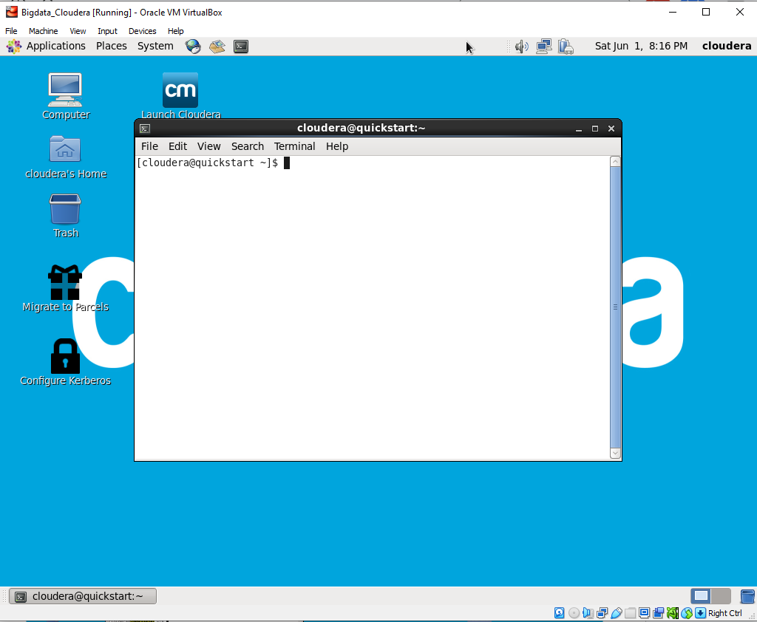

a2 Can also see by command **“whoami”**

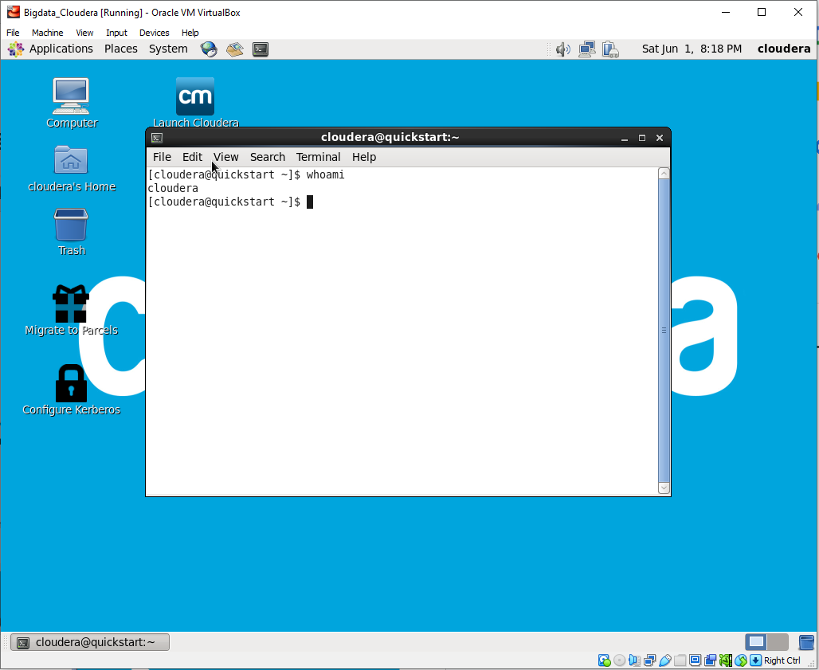

1. b1 “**Quickstart**” Host name of operating system

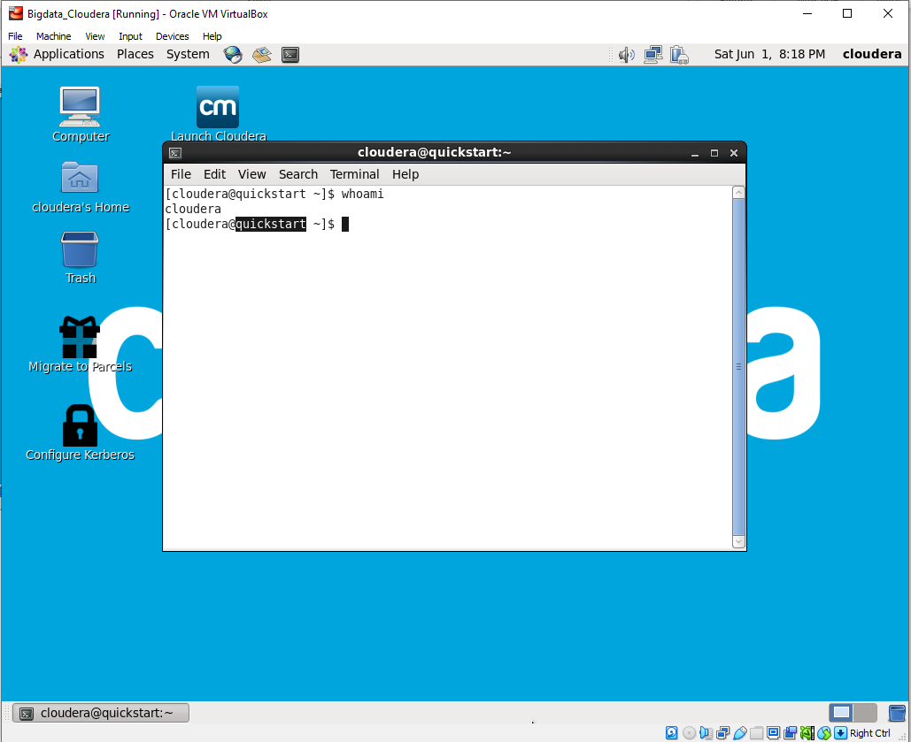

b2 Can also see Hostname by command “**hostname**”

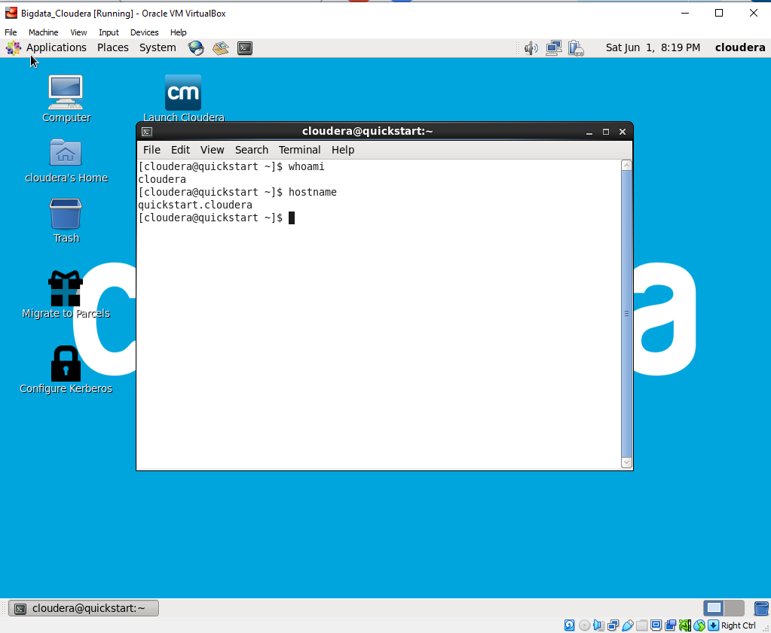

1. ~ (tilt) indicates home directory

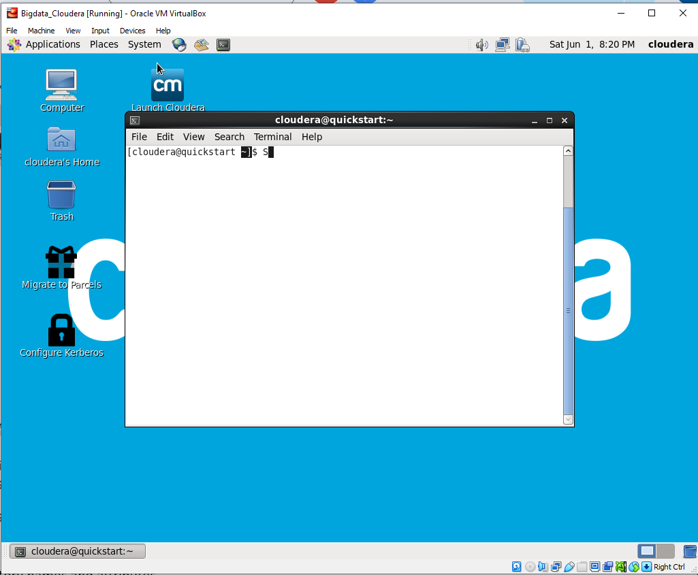

1. Pwd = Present Working Directory

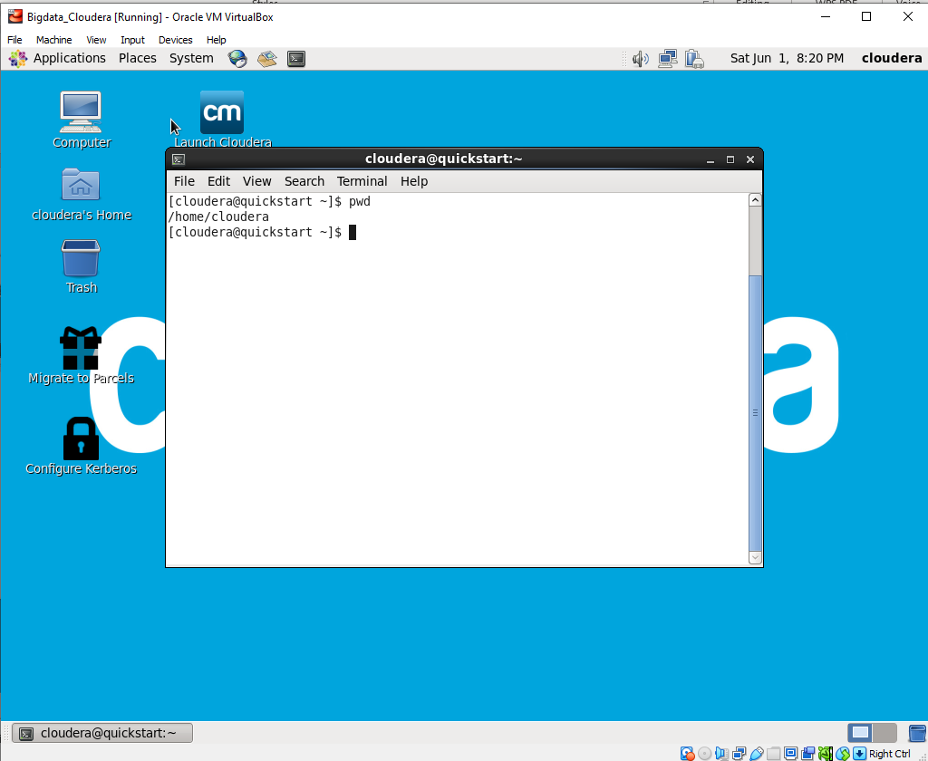

1. [ls = list file and directory names and attributes](https://www.mkssoftware.com/docs/man1/ls.1.asp)

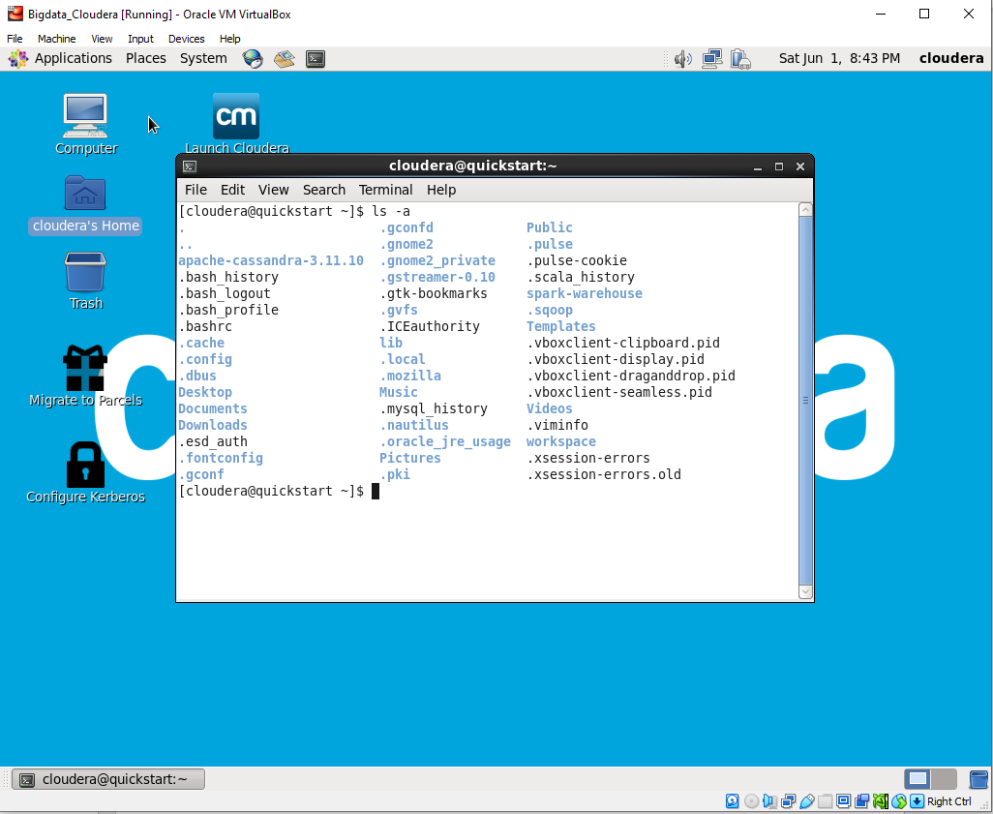

‘’ctrl + h ‘’ to see hidden files in window

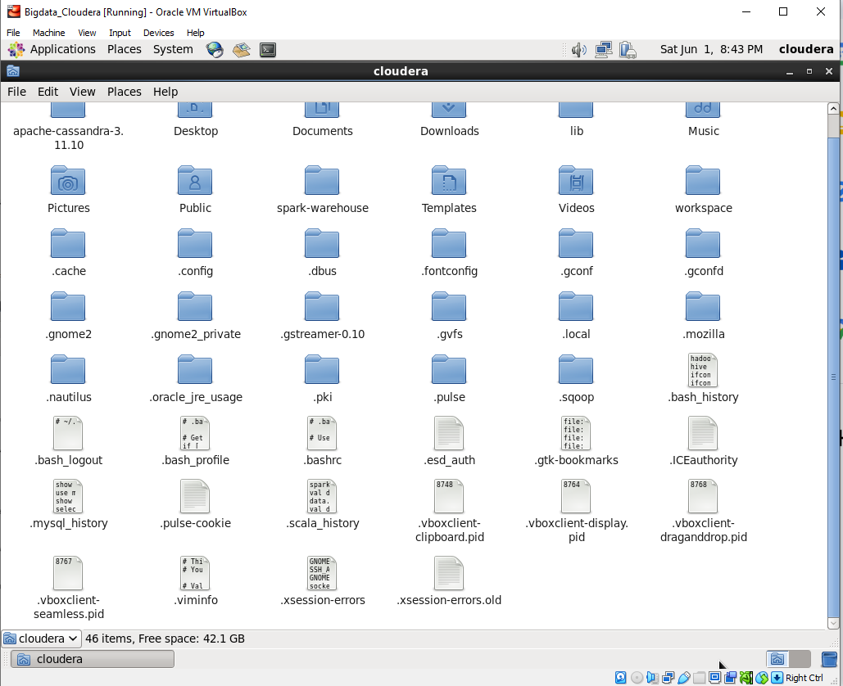

1. Jps- (with sudo) java virtual machine process status

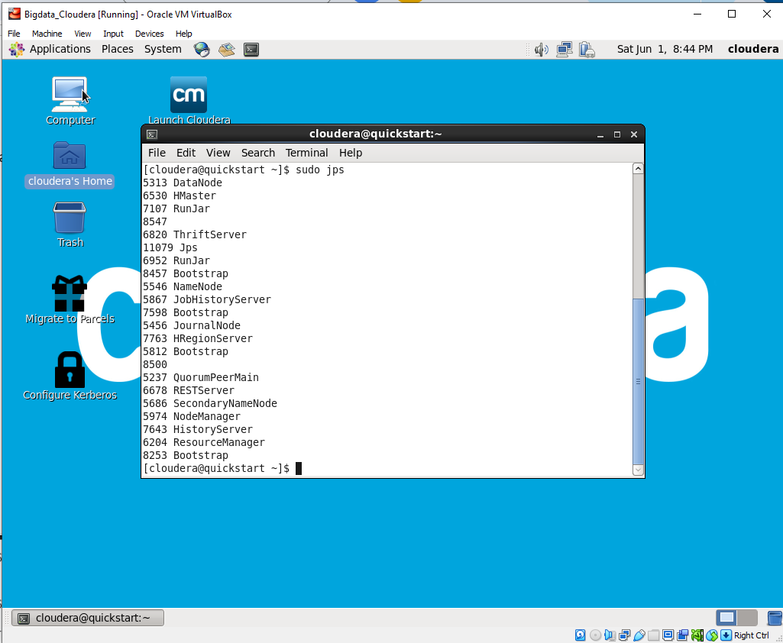

1. Cd – Change Directory

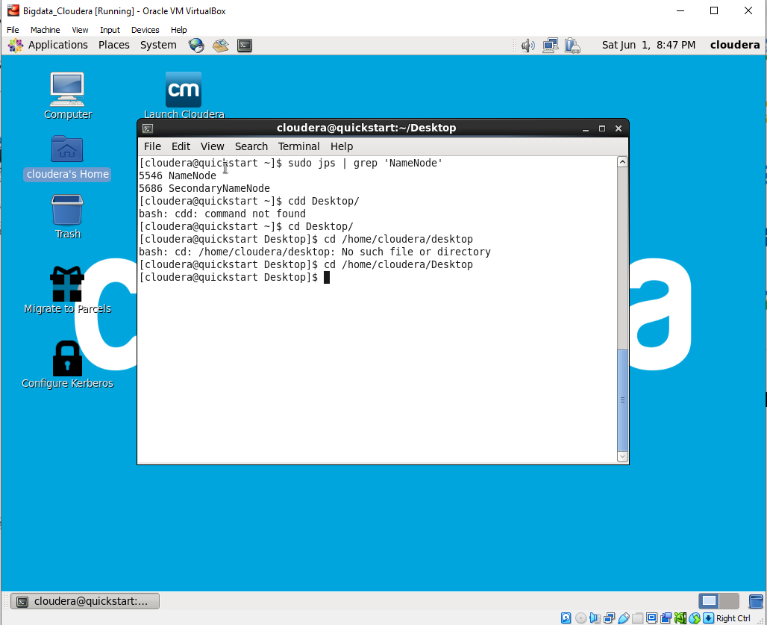

1. Man – Manual and info - Info

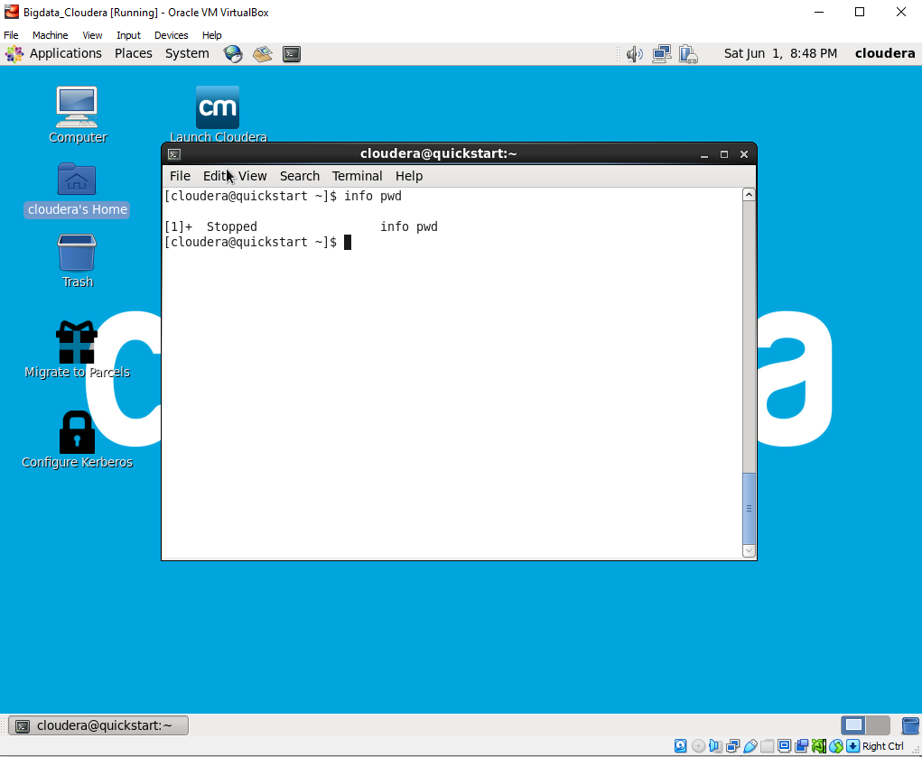

1. Cat – Creating and Viewing file

Display, Copy, Combine and create new text file.

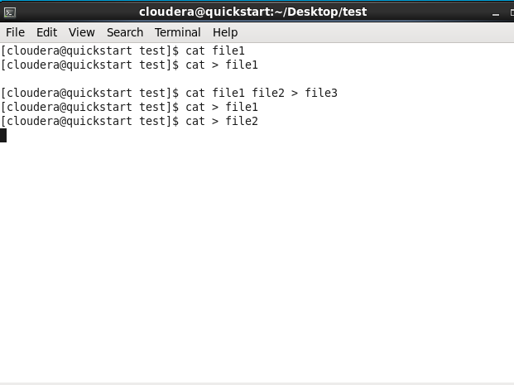

Rm – Remove file

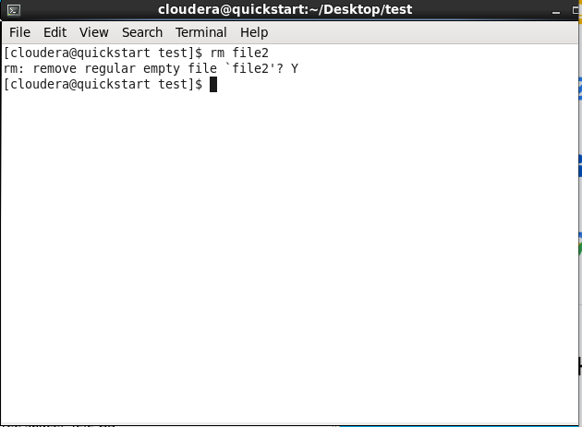

1. Mv – Move/ Rename ( File and Directory both)

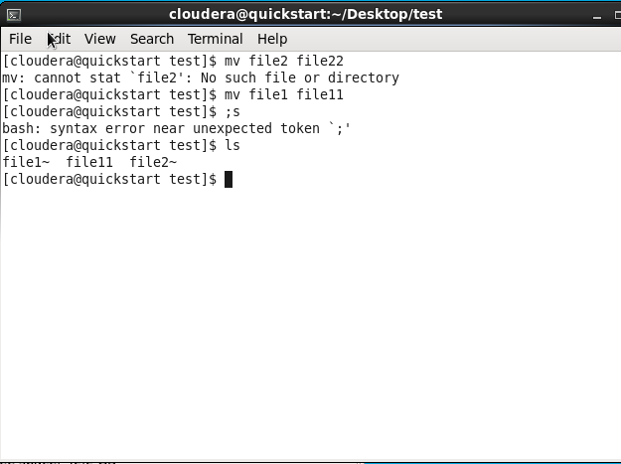

Moved /test/file11 to /test/testtest/file11

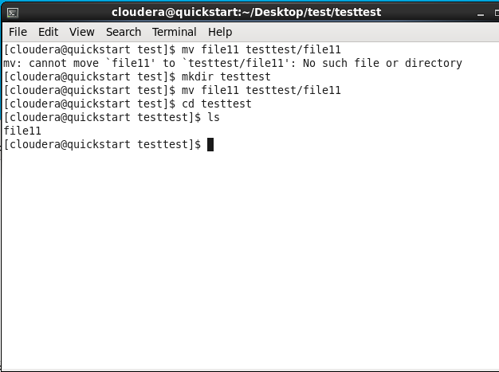

Su – supper user

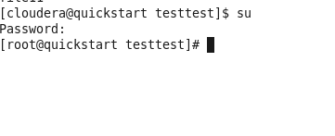

Sudo prefix to command – Do as super-user. Commands executed are logged. Enter own password. Password is retained for 15 mins as super user.

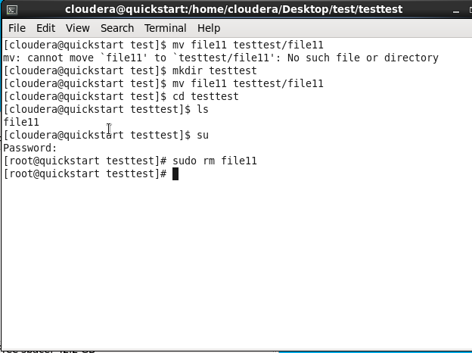

1. Mkdir – Create directory



1. Rmdir – remove directory

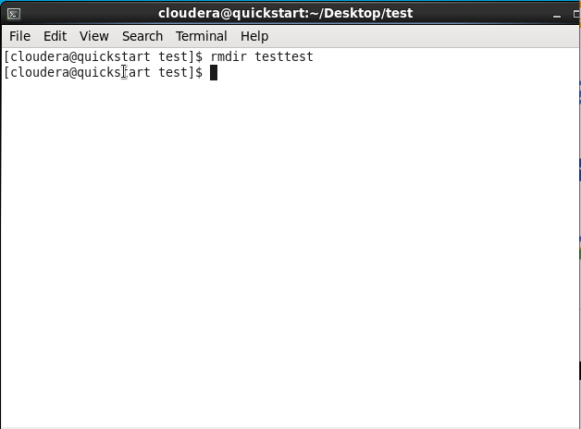

1. History – List of commands executed

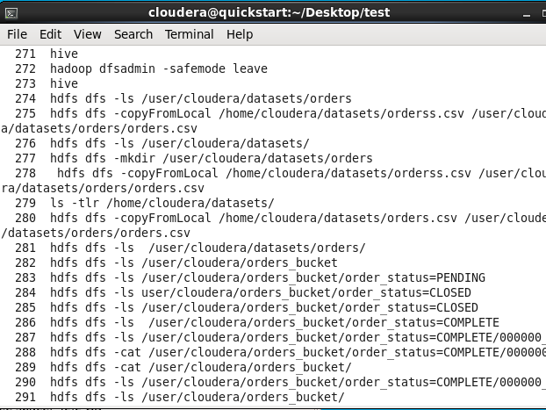

1. Clear – Clear the window

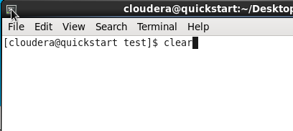

1. Chown – Change owner

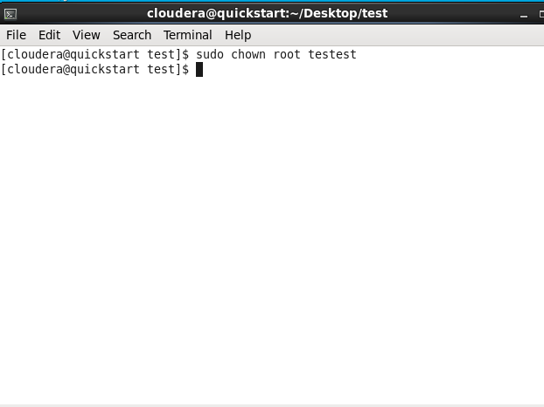

1. Chmod – Change mode/authority

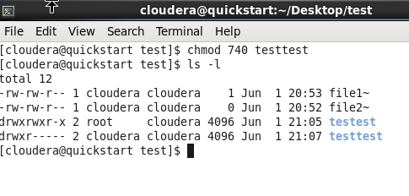

Owner, Group and Other permission

R – 4, w – 2, e – 1

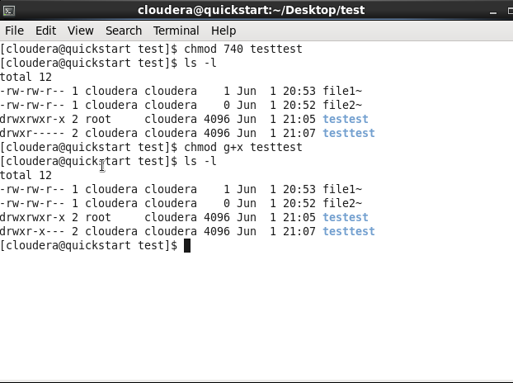

It’s the other way

+ to add, – to remove

u user/owner, g-group, o-other and a –all

1. Chgrp – change group

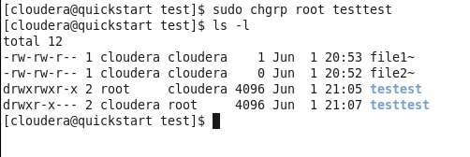

Write the following lines in a file and save it as 'hello.sh'.

#!/bin/bash

echo "Hello, World!"

or explain ‘pgm.sh’

echo “Hello, What is yout Name”

read name

echo “$name, nice name”

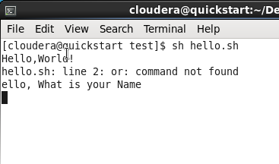

**How to install software’s (eg: open office/libreoffice):**



**wget --no-check-certificate https://downloads.sourceforge.net/project/openofficeorg.mirror/4.1.15/binaries/en-US/Apache_OpenOffice_4.1.15_Linux_x86_install-rpm_en-US.tar.gz** 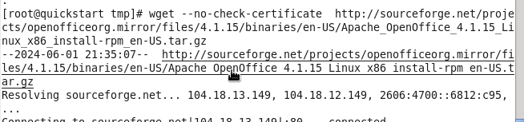

* **tar -zxvf OOo_3.3.0_Linux_x86-64_install-rpm-wJRE_en-US.tar.gz**

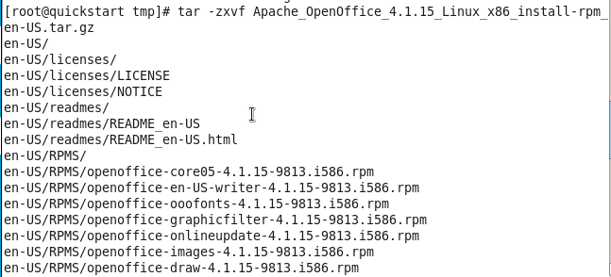

* **rpm -Uvh OOO330_m20_native_packed-1_en-US.9567/RPMS/*.rpm**

rpm-UVh en-US/RPMS/*.rpm 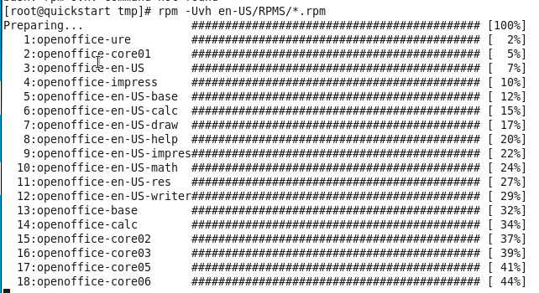

**rpm -Uvh OOO330_m20_native_packed-1_en-US.9567/RPMS/desktop-integration/openoffice.org3.3-redhat-menus-3.3-9556.noarch.rpm**

đổi thành

rpm -Uvh en-US/RPMS/desktop-integration/openoffice4.1.15-redhat-menus-4.1.15-9813.noarch.rpm

